

MuleSoft Exchange

(Configuration for CeG)

Anypoint Exchange Information (eGov, Karnataka)



Version : V1.0

**Document Control**

|  |  |
| --- | --- |
| **Document Information** | |
| *Document Name* | *MuleSoft Exchange* |
| *Client* | *Department of e-Governance, Government of Karnataka* |
| *Document Author(s)* | *Prashanth Nuggehalli Chandrashekar* |
| *Document Version* | *V1.0* |
| *Document Status* | *Work In Progress (W.I.P)* |
| *Date Last Update* | *23rd Nov 2020* |
| *Date Released* | *12-Jan-2021* |

**Document Edit History**

|  |  |  |  |
| --- | --- | --- | --- |
| **Version** | **Date** | **Additions/Modifications** | **Prepared / Revised by** |
|  |  |  |  |
|  |  |  |  |
|  |  |  |  |
|  |  |  |  |

**Document Review/Approval History**

|  |  |  |  |  |
| --- | --- | --- | --- | --- |
| **#** | **Name**  ***(Prepared By)*** | **Organization/Title**  ***(Approved By)*** | **Date**  ***(Approval Date)*** | **Comments**  ***(Description)*** |
|  |  |  |  |  |
|  |  |  |  |  |
|  |  |  |  |  |
|  |  |  |  |  |

*This page is intentionally left blank*

**Table of Contents**

**Introduction** **6**

**How to ?** **6**

Login 6

Landing Page 7

Exchange Landing Page 7

**References** **8**

https://docs.mulesoft.com/exchange/ 8

# Introduction

Anypoint exchange is the marketplace for connectors, templates, examples, and APIs. Exchange is useful to discover and use prebuilt assets from the MuleSoft ecosystem, or use Exchange to save, share, and reuse internal best practices. More information on exchange is provided in reference section and reader is encouraged to explore the link un reference.

Under the existing requirements, the Exchange activities and exchange artefacts are to be built per department per requirement.

## How to?

### Login

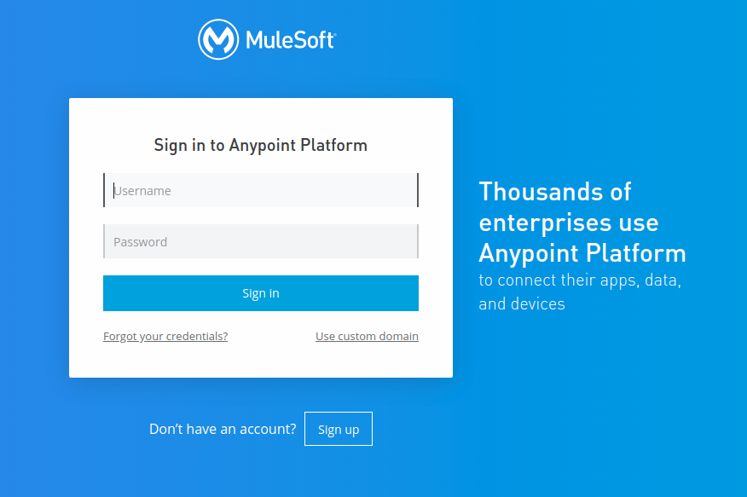

**Link** : <https://anypoint.mulesoft.com/login/>

**Username** : gok-esb-admin

**Password** : Ce3U$er****

### Landing Page

### Exchange Landing Page

Select or choose Exchange

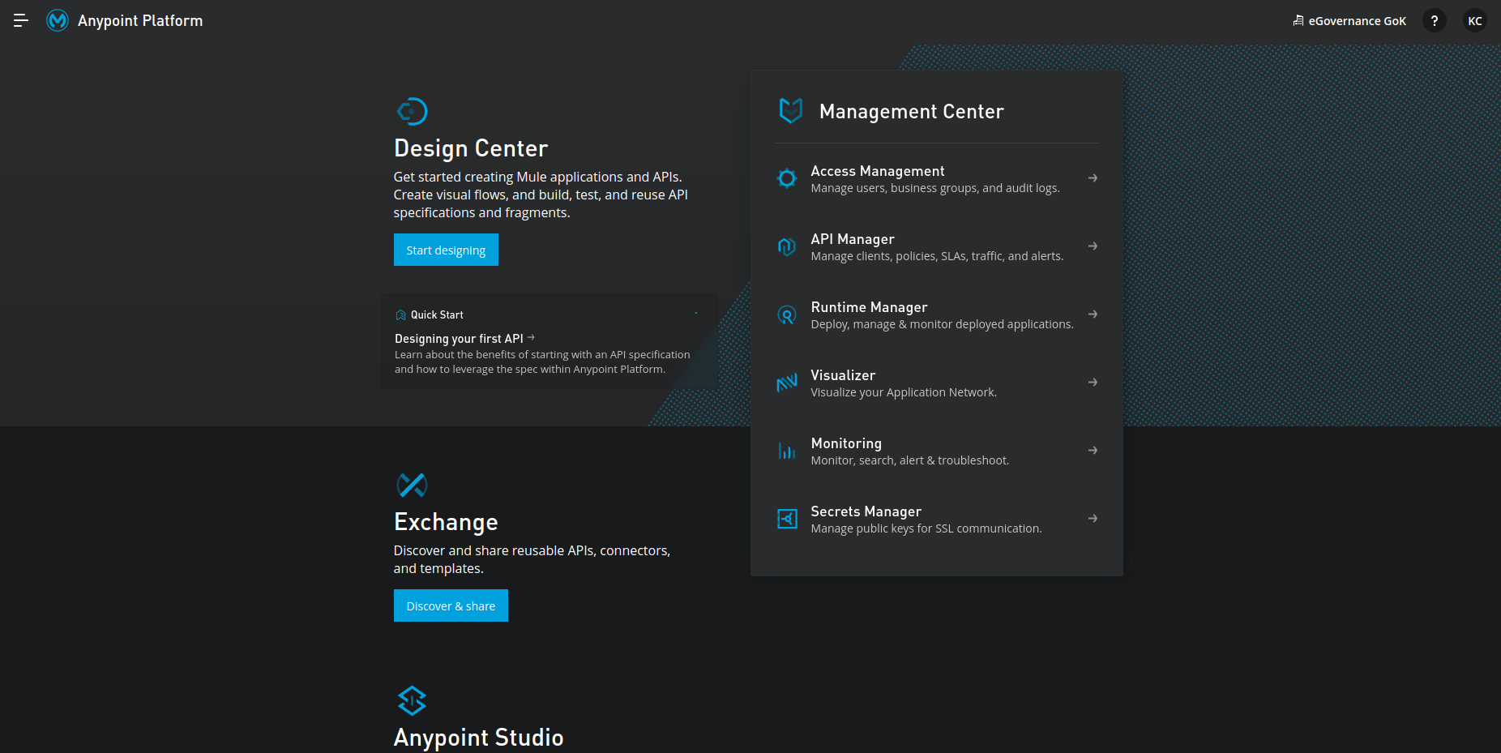

Exchange Landing Page

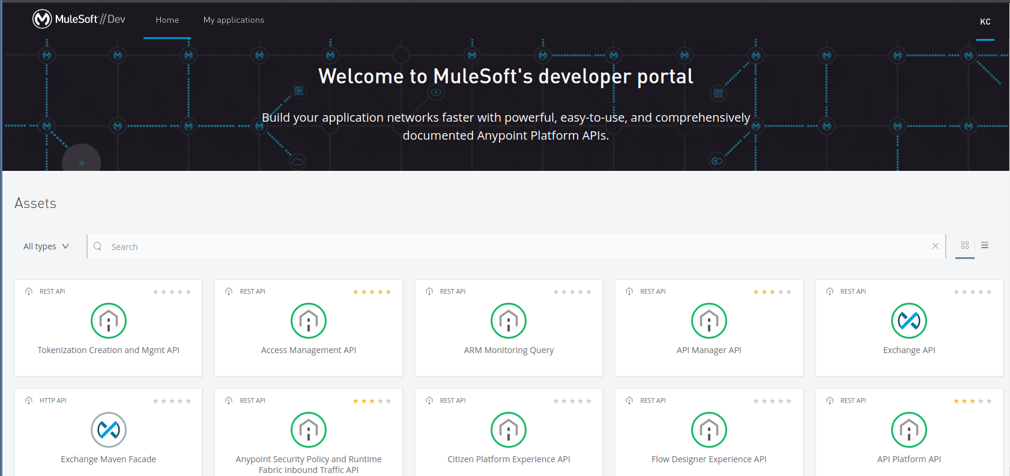

## References

### <https://docs.mulesoft.com/exchange/>

### 